Table of Contents
Introduction to N-grams 1
Probabilistic Language Model 1
Models 1
Markov Assumption 1
Markov model 1
Perplexity is the inverse of probability 2
Smoothing: Add one smoothing 2
Interpolation 2
N-gram Smoothing 2
Smoothing 2

Introduction to N-grams

Probabilistic Language Model
A model assigns a probability to every sentence in English in such a way that more likely sentences (in some sense) get higher probability.

Models
- unigram: words generated one at a time, drawn from a fixed distribution.
- bigram: probability of word depends on previous word.
- tag bigram: probability of part of speech depends on previous part of speech, probability of word depends on part of speech.
- maximum entropy: lots of other random features can contribute.
- stochastic context free: words generated by a context-free grammar augmented with probabilistic rewrite rules.

Markov Assumption
The term Markov assumption is used to describe a model where the Markov property is assumed to hold, such as a hidden Markov model.

Markov model
A Markov model is a stochastic method for randomly changing systems where it is assumed that future states do not depend on past states. Or probability of moving to a given state depends only on the current state.

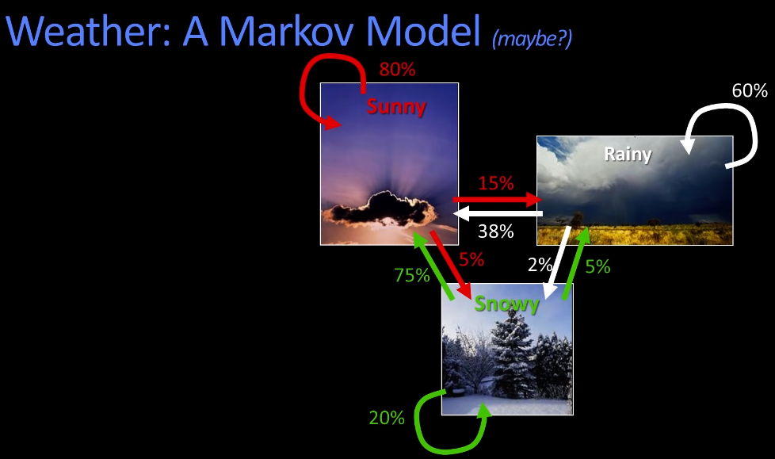
Perplexity is the inverse of probability

Smoothing: Add one smoothing
To handle 0 probability issue if given word is not present.

Interpolation
Sometimes it helps to use less context
- Backoff:
  - use trigram if you have good evidence
  - otherwise bigram, otherwise unigram
- Interpolation:
  - mix unigram, bigram, trigram

N-gram Smoothing
- Add-1 smoothing
  - OK for text categorization, not for language modeling
- The most commonly used method
  - Expended Interpolation Knesser-Ney
- For very large N-grams like the web
  - Stupid backoff

Smoothing
- The simplest way to estimate LMs, MLE, is problematic on sparse data
- Good truing smoothing
  - Use frequency of frequency
  - For unseen example = N1/N
  - Save a bit from each term
- Add 1 smoothing
- Witten Bell smoothing
  - ”Witten-Bell”-smoothing is an instance of the recursive interpolation method
- Kneser-Ney Smoothing

